# **Sample Project**

* [MobileAutomation_Appium](https://github.com/ashishbaraiya/MobileAutomation_Appium)

# **References**

## **Tools**

* Eclipse
* Android Studio (SDK & AVD)
* **Chromedriver.exe version 2.3 -** C:\Program Files (x86)\Appium\node_modules\appium\build\chromedriver\windows\chromedriver.exe
* Use – **Google Chrome.apk version 29**
* Used **ARM emulator**

## **Libraries**

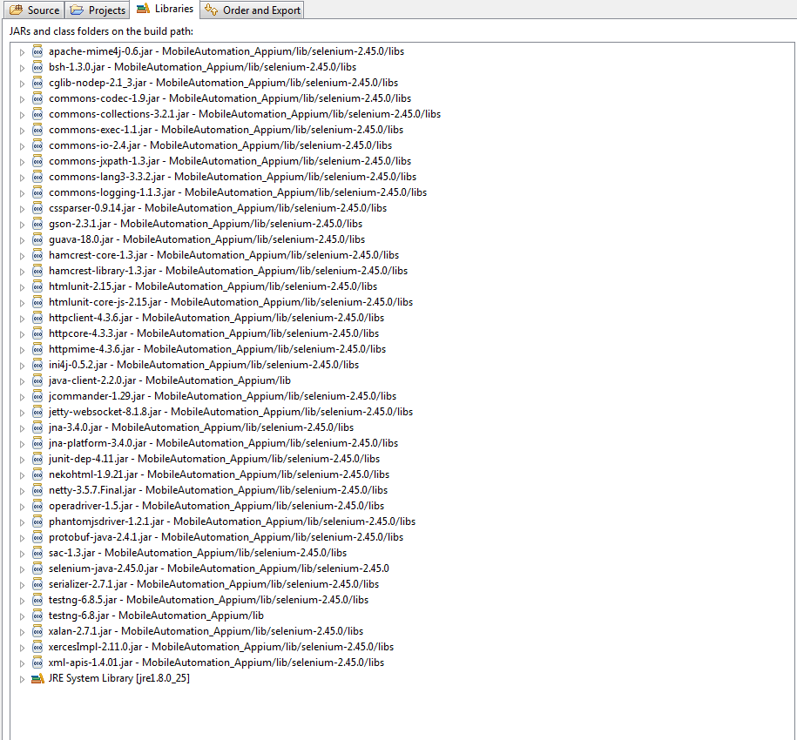

# **Start Appium**

* [Download](https://bitbucket.org/appium/appium.app/downloads/) and install latest version of Appium
* Run the Appium after installation by executing the installed Appium file from the Start menu.

# **Start the Emulator/Real device**

* Invoke the Emulator or attach the real device.
* For emulator, I have used below info
* Device: Nexus 4
* Target: Android 5.0.1 – API Level 21
* CPU/ABI: ARM (armeabi-v7a)

**Note:** Checkout below info for emulator configuration used for POC.

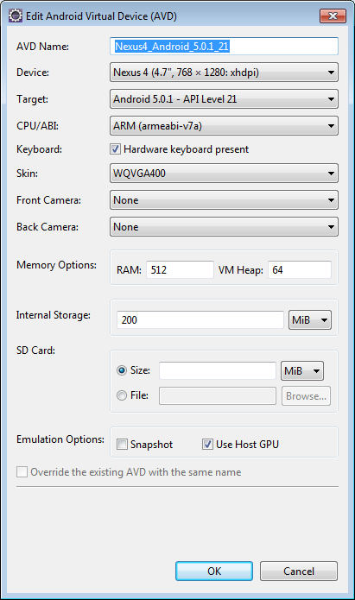

# **Challenges**

* In case of encountering Chrome driver redirect error, check out the appropriate version of Chromdriver.exe and Chrome browser installed on emulator or real device. Make sure that you are using Chromedriver.exe version **2.3** and Chrome.apk version **2.39**.This combination has been tried and tested and working fine.
* In case the GUI is not being shown on the emulator/device then make sure that you choose **Use Host GPU** in the *Emulator Options* section of **AVD** while configuring your device/emulator with **Android Virtual Device Manager (AVD)**. See the below snapshot for more info.

